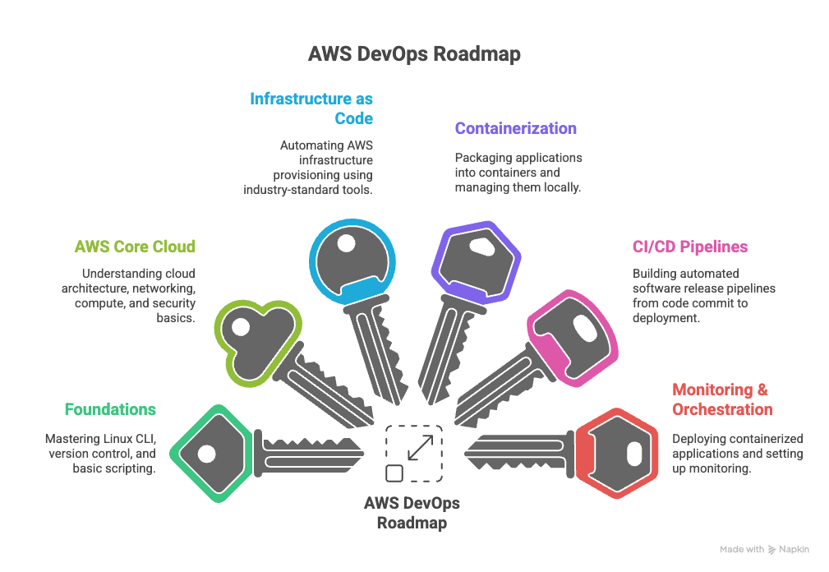

Here is the 6-month, tool-focused roadmap for AWS DevOps beginners.

🚀 6-Month AWS DevOps Roadmap (Beginner to Job-Ready)
Month | Focus Area | Goal | Key Tools & AWS Services to Master
1 | Foundations | Master Linux CLI, version control, and basic scripting. | Linux (Bash Scripting), Git & GitHub, Python (Basics)
2 | AWS Core Cloud | Understand cloud architecture, networking, compute, and security basics. | AWS IAM, AWS VPC, AWS EC2, AWS S3
3 | Infrastructure as Code (IaC) | Automate AWS infrastructure provisioning using the industry-standard IaC tool. | Terraform, AWS CloudFormation (as a reference)
4 | Containerization | Package applications into containers and manage them locally. | Docker (Containerization), YAML (Configuration language)
5 | CI/CD Pipelines | Build a complete, automated software release pipeline from code commit to deployment. | Jenkins (or GitHub Actions), AWS CodeDeploy (Deployment)
6 | Monitoring & Orchestration | Deploy a containerized application and set up monitoring for it. Build final portfolio projects. | AWS ECS (Container Orchestration), AWS CloudWatch, Prometheus/Grafana (Visualization)

🛠️ Essential Tools and Brief Descriptions
This list contains the mandatory tools you must master within 6 months, prioritizing skills highly sought after in India.

I. Foundational & Scripting Tools (Month 1)
Tool | Category | Brief Description
Linux (Bash) | Operating System/Scripting | The command-line interface and scripting language for most servers. Essential for automation and server management.
Git & GitHub | Version Control | The distributed system for tracking code changes. GitHub is the platform for hosting repositories and team collaboration (Pull Requests).
Python | Scripting Language | The multi-purpose programming language used for writing automation scripts, serverless functions (AWS Lambda), and interacting with cloud APIs.
SSH | Networking Protocol | Secure Shell. Used to remotely log into and manage Linux servers (EC2 instances) securely over the network.

II. Core AWS Services (Month 2)
Tool | Category | Brief Description
AWS IAM | Identity & Access Management | Manages users, groups, and roles, defining who can access what on AWS. Crucial for security and adhering to the principle of least privilege.
AWS VPC | Networking | Virtual Private Cloud. Your isolated virtual network within AWS where you launch your resources (subnets, routing tables, security groups).
AWS EC2 | Compute | Elastic Compute Cloud. Provides customizable, scalable virtual machines (servers) that you provision, configure, and manage.
AWS S3 | Storage | Simple Storage Service. Highly scalable, durable object storage used for storing raw data, backups, logs, and build artifacts.

III. Infrastructure & Configuration (Month 3)
Tool | Category | Brief Description
Terraform | Infrastructure as Code (IaC) | An open-source tool by HashiCorp that allows you to define and provision entire cloud infrastructure using human-readable HCL (HashiCorp Configuration Language).
Ansible | Configuration Management | An agentless automation tool that uses SSH to push configuration and deployment instructions (Playbooks) to servers. Used to install software on provisioned EC2 instances.

IV. Containerization & Orchestration (Month 4 & 6)
Tool | Category | Brief Description
Docker | Containerization | Packages an application and all its dependencies into a self-contained unit (Container Image) to ensure consistent execution across environments.
AWS ECS | Container Orchestration | Elastic Container Service. AWS's fully managed, highly scalable service for running and coordinating Docker containers. Recommended starting point over EKS for beginners.

V. Continuous Integration/Delivery (Month 5)
Tool | Category | Brief Description
Jenkins | Automation Server | The leading open-source automation server for building, testing, and deploying software projects (CI/CD). Integrates with nearly all other tools.
AWS CodeDeploy | Deployment Service | Automates software deployment to a variety of AWS compute services (EC2, ECS, Lambda, etc.), minimizing downtime during releases.
(Alternative) GitHub Actions | CI/CD | An integrated feature of GitHub to automate workflows directly within the repository, providing a modern alternative to Jenkins.

VI. Monitoring & Observability (Month 6)
Tool | Category | Brief Description
AWS CloudWatch | Monitoring | AWS's built-in monitoring and observability service that collects logs, metrics, and events to provide insights into resource performance and application health.
Prometheus & Grafana | Open-Source Observability | Prometheus collects real-time system metrics, and Grafana is the visualization layer used to create dynamic dashboards from those metrics. This is a highly desired combo in India.

- Primary Goal: AWS Certified Solutions Architect – Associate (SAA-C03)
  - Why? This certification is the global benchmark for understanding core AWS services and architectural best practices (EC2, VPC, S3, RDS, IAM). It is the most common entry requirement for cloud roles.
- Secondary Goal: HashiCorp Certified: Terraform Associate
  - Why? Having an IaC certification shows an immediate, job-ready skill and validates your mastery of automation beyond basic AWS knowledge.

